1. 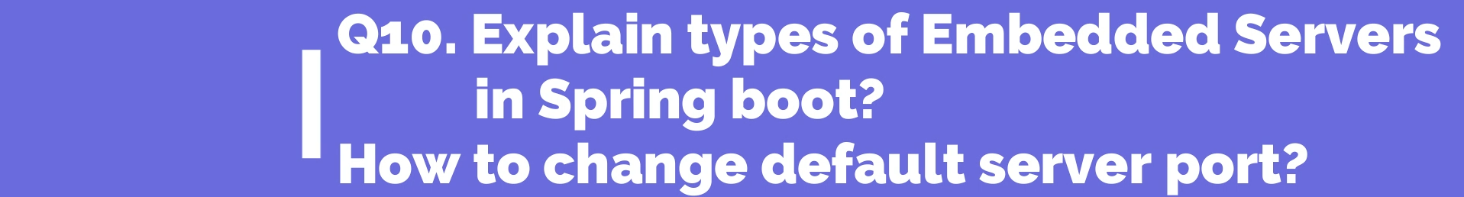
2. 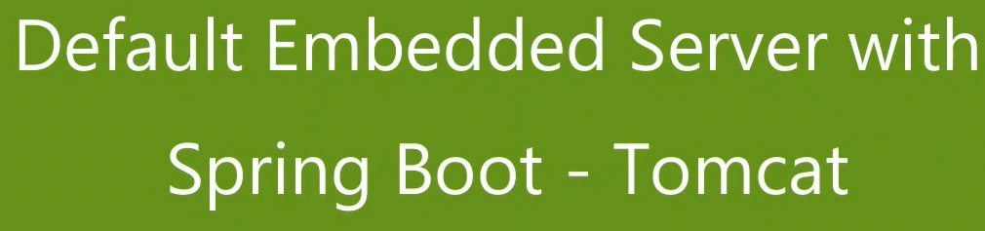
3. 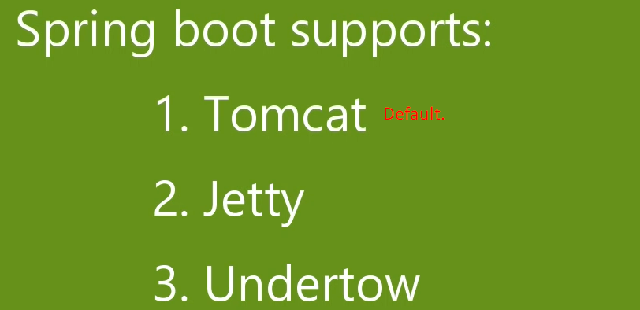
4. 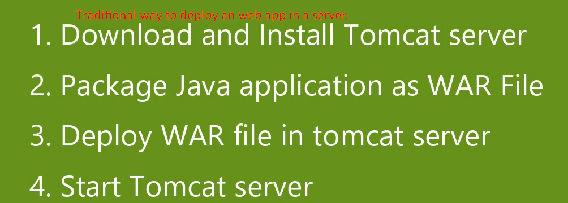
5. 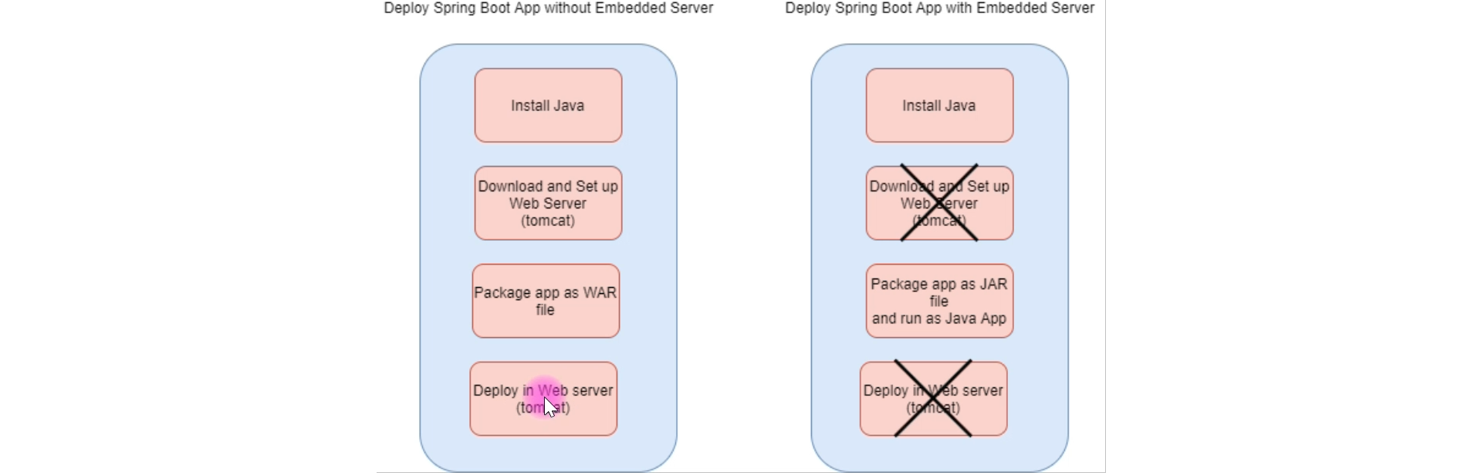
6. Let’s see where tomcat dependency has been added and how?
   1. 
   2. 
   3.  
7. How to replace tomcat with jetty or undertow?
   1. 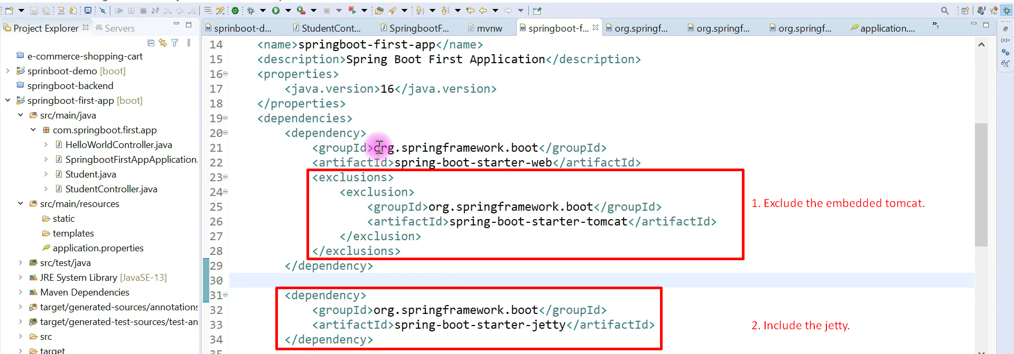  
      
   2.  